Assignment (Bash Command)

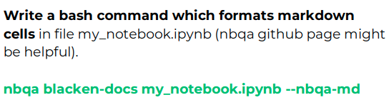

Solution

- We have unformatted python code in markdown cell.
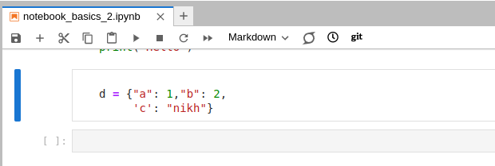

- Now we use nbqa and blacken-docs command to format our code.
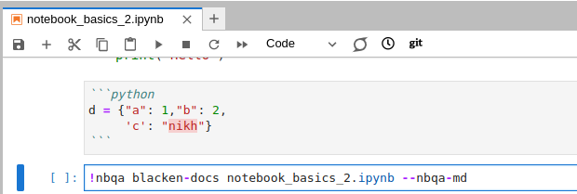

- After running command it give output.
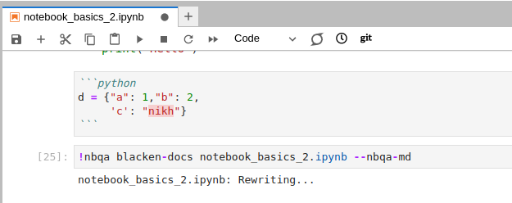

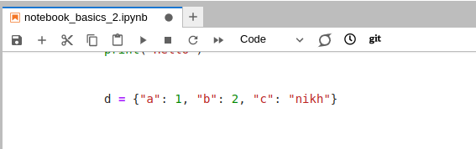
- After refreshing the notebook we get updated code.

